Forums / Week 4 Forum - Extra Credit
Week 4 Forum - Extra Credit

The Most Important Part of Emergency Planning ( 9 messages - 9 unread ) New messages Hide Full Description
Week 4 Forum
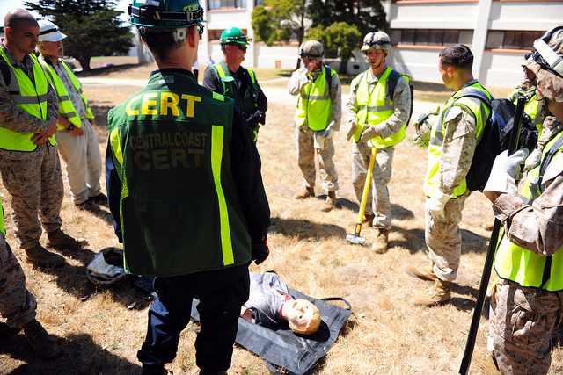
This is an optional assignment for extra credit, to be added on to your final grade.
Our reading, thus far, has discussed multiple aspects of emergency planning, including planning structures and guidelines, identification of planning missions and goals, and so forth. Considering what you’ve learned thus far, identify which component you consider the most important part of the emergency planning process. Be sure to defend your answer using what you have learned thus far. Please start a new thread when creating your initial post and write any responses to others within their existing discussion threads. To receive full credit, be sure to respond to at least two of your classmates’ postings.
Please write a minimum of 250 words for your initial post due by 11:55pm ET on Thursday.
Please thoughtfully reply to at least two other students due by 11:55pm ET on Sunday.
Your replies must contain a minimum of 75 words.
Grading Rubric: All forums will be scored according to the Forum Grading Rubric.

